AWSA ANNUAL SUMMER MEETING

August 6th, 2022
Maize, Kansas

Agenda
- Call to Order
- Introduction and Roll Call
- Announcement of Quorum
- Opening Administrative Motions and Housekeeping Matters
- Appointment of Parliamentarian
- Review of Agenda
- Confirmation of Voting Roll
- Administrative Matters
- Adoption of Agenda
- Presentation of Service Awards
- Review and Approval of the 2022 Mid-Winter Meeting Minutes
- Ratification of the Board of Directors Electronic Ballots since February 1st, 2022
- Nominating Committee Report
- USAWSWS Executive Director Nate Boudreaux’s Report (Report attached)
- AWSA President Lyman Hardy’s Report (Provided verbally)
- AWSA Treasurer’s Report (Motion to accept)
- IWWF PanAm Report – Dana Garcia
- Standing Committee Reports
- Towboat Committee – Will Bush & George Lindy, Chairs (Report attached)
- Rules Committee – Richelle Muhlitner, Chair (Report attached)
- Announcers Committee – Hank Longo, Chair
- Awards Committee – Lori Krueger, Chair
- Drivers Committee – Greg Badal, Chair (Report attached)
- Bylaws Committee – Jeff Clark, Chair (Report attached)
- International Activities Committee – Jeff Smith, Chair (Report attached)
- Judges & Scorers Committee – Robert Howerton, Chair (Report attached)
- Junior Development Committee – Allison Blair, Chair (Report attached)
- Safety Committee – James Cawthern, Chair (Report attached)
- Seeding Committee – Kirby Whetsel, Chair
- Skier’s Qualification – Dave Allen, Chair
- Technical Committee – Jerry Jackson, Chair (Report attached)
- Regional Recommendations
- Eastern Region
- Midwest Region
- Southern Region
- South Central Region
- Western Region
- Old Business
- New Business
- Announcement of Date & Time of January 2023 Board Meeting – January 28th, 2023 at 8:00 a.m. in Auburndale, Florida
- Call for Adjournment

AWSA Nominating Committee Report
Summer Board of Directors Meeting – August 6th, 2022

Nominees for 2022 AWSA Officers

AWSA President: Lyman Hardy

AWSA Vice President: Kate Knafla

AWSA Chairman of the Board: _____________________

AWSA Secretary: Delaina Downes

AWSA Treasurer: Cynthia Logan

Submitted by: Kate Knafla, Chairperson

USAWSWS Executive Director’s Report
Summer Board of Directors Meeting – August 6th, 2022
All,
I have several agenda items I’d like to discuss with AWSA Exec and/or BOD in the near future. See below – some updates, some discussion points.
- Membership & Sanctioning Update
  - 13,935 total members (+1,409 from this time last year)
    - 6,668 AWSA members (+702 from this time last year)
    - For those naysayers that balked and said Safe Sport training requirement would hurt overall membership that assertion was simply untrue (at least thus far)
  - 419 sanctioned tournaments (-42 from this time last year)

- AWSA Nationals Registration Update – Although AWSA membership is up overall, registration for Nationals is down about 150 from this time last year. There were some IT issues that caused the online registration to be delayed by few weeks. An email went out last week to 1,600 AWSA members who may have qualified for Nationals asking them to register.

- Digital Membership Update – AWSA provided postcards to each of the ski companies that had a QR code to the digital membership registration. We also included this offer in a MasterCraft e-newsletter that went to 39,000 people and a Bart’s Water Sports e-newsletter that went to 130,000. Unfortunately, the conversation rate on both wasn’t great. To date we’ve generated 143 free digital members. We can track specifically the conversation rate on the postcard vs. the emails but given when these members signed up vs. when the email went out we have a decent idea. MasterCraft generated 77 and Bart’s 15. The “other” 50 would be from the AWSA cards and from email journeys that guest members from Basic Skills and Get on the Water events go through – they get a series of

- Constant Contact Email (Need to Discuss)- We keep extending our contract with the constant contact email service for SDs and AWSA regions to use vs. sending us text to send emails through Salesforce. This is a $2,520 annual cost for us. Over the last 12 months there have been a total of 14 emails sent thru Constant Contact (5 from South Central, 3 from USA-WSWS for Get on the Water, 2 from AWSA, 2 from Adaptive, 1 from Eastern Region, 1 from Barefoot) – that breaks down to about $180 an email (not very cost effective). I’d like to discontinue this when the contract expires at the end of August. AWSA Regions would still be able to send emails to your constituents but it would need to be done through HQ (via Salesforce). The membership system should have email capability in the next product release later in 2022 but until then, HQ can send any communication that is needed.

- Rankings list / PB badges (Need to Discuss) –We used to print out and mail actual certificates to those ranked #1 on the ranking list in each division at the end of each ski year. This hasn’t been done since 2020 and is not feasible any longer (actual printing and mailing a hard copy certificate). We are looking to create a new certificate/graphic to share with all of those ranked #1 in each division on the ranking list. We’ll email it to them in a format that is easily shared on social media channels. Once the template of the certificate is complete, will share with AWSA for input. We’ll go back and create for 2021 and have for 2022 as well. It’s about 100 unique certificates/graphics each year. Additionally, we are creating a similar social graphic for personal best badges. The initial idea would be we’d create a Google form where skiers can input their personal best data (name, division, event, score, date, etc.) and we’d take that data and put it into a shareable social graphic and email back to them. Depending on volume, we could make these as they come in; however, the plan would be to create a dynamic webpage where the user puts in their info and the graphic automatically populates and the user downloads and then shares on their social channels. Will get a quote on the cost to build this. I’d like AWSA to consider allocating some of the $$ towards a project like this vs. a new website.

- Where2WaterSki.com (Need to Discuss) (+ Google Ad grant – we would apply for a Google Ad grant worth $10k/month in Google Ad credits for nonprofits). Objective: Create a microsite where users can put in their zip code and find a place to water ski near them. The site would also house basic information for novice skiers like instructional articles and videos, a listing of camps/ski schools and tournaments and basic information about the various types of water skiing (3-event, show ski, barefoot, etc.). The data that populates the listing would be dynamic and tied to the member management system (for clubs) and the event management system (for basic skills and Get on the Water events). Other parts of the data would be static like the camps and ski schools and cable park listings. We are getting quotes from website developers and marketing agencies now. I’d like AWSA to consider allocating some of the $$ towards a project like this vs. a new website.

- Shredding records in old storage unit (Update + Need to Discuss) – Boudreaux informed the USA-WSWS board that we plan to discontinue renting the Polk City, Fla. storage unit in October (possibly January now). The organization currently has two storage units – Polk City and Auburndale, Fla. The cost of storage has risen by more than 30% and we currently pay $1,300 annually for the Polk City unit which houses floor to ceiling boxes of old paperwork dating back to the 1950s (mostly AWSA stuff like membership records, financials, driver ratings/tests, etc.). We will move the last 7 years of financial data to the new storage unit in Auburndale and shred the rest. We need to keep 7 years of financials. Membership records and financials are now stored digitally (starting in 2020). The cost to shred this volume of paper would be $1,200-$1,500 but would eliminate the annual cost of the Polk City unit moving forward. The Auburndale unit is climate controlled and currently houses file cabinets with old issues of the Water Skier Magazine, photos, some water ski artifacts from the old office space, sponsor banners and other USA-WSWS marketing materials (pull up banners, table skirts, banquet settings, etc.). This unit is $225/month for $2,700 annually. If anyone from AWSA has a need/want to go thru this storage unit to save anything now is the time to do it.
Nate Boudreaux
Executive Director

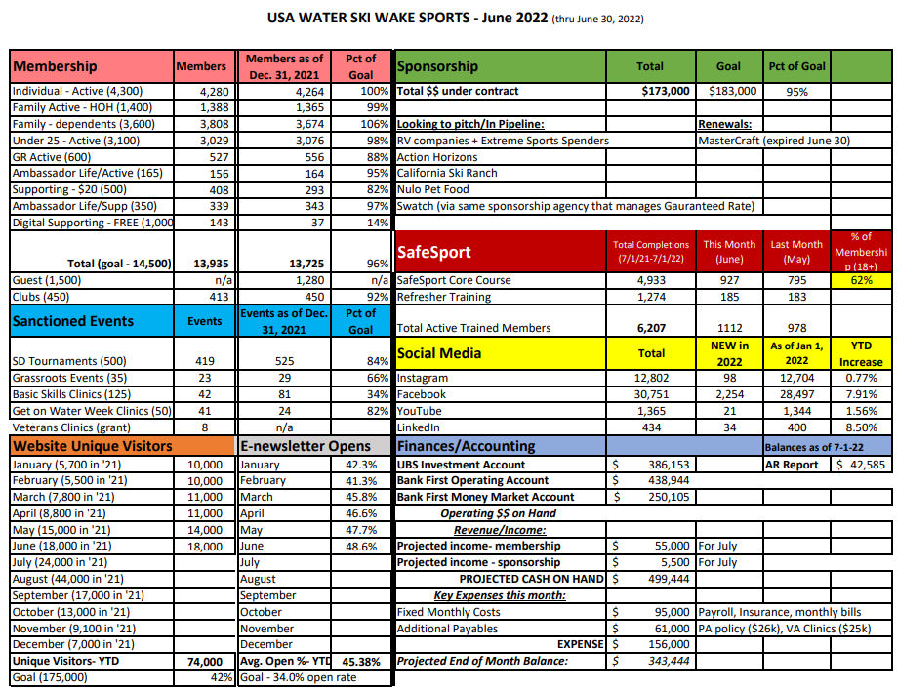

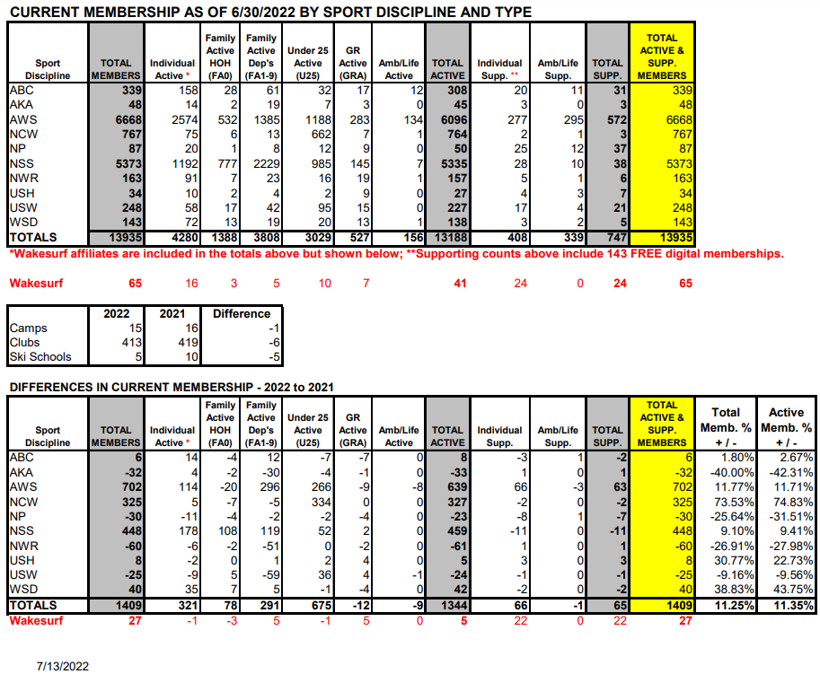

AWSA Towboat Committee Report
Summer Board of Directors Meeting – August 6th, 2022

To: AWSA Board of Directors

From: Will Bush & George Lindy

ACTION ITEM: Modify Current Policy – Reimbursement for Costs Incurred

Background

The AWSA BOD previously approved the policy for a LOC to reimburse towboat owners $25.00/hour (as recorded on the hour meter) for use of their boats in sanctioned AWSA tournaments.

One of the AWSA Towboat Manufacturers has requested the hourly reimbursement rate be increased to $50.00/hour. The rationale is that cost for maintenance and depreciation for use of a towboat is approximately $75 per hour. Also, the cost of fuel to travel to an event has escalated.

As we have experienced, there are fewer and fewer “Promotional Boats” to support three event sanctioned tournaments. Without manufacturer or factory support many of these boats being used in tournaments are now “personally owned boats”. As such, depreciation and maintenance costs associated with these boats are now becoming the sole responsibility of the boat owner.

Revised Policy – Reimburse Boat Owners for Costs Incurred for Use

A Local Organizing Committee (LOC) must reimburse a boat owner(s) for use of a boat for any event (excluding Regionals and Nationals), on an hourly basis. This provision includes promo boats, individually owned boats, club owned boats, etc. The recommended reimbursement rate is $50 (Fifty dollars) per hour of use, recorded from the boat’s hour meter. The boat must be an Approved Tournament Towboat with valid insurance as required by USAWSWS. The boat owner has the option to decline reimbursement and/or make other arrangements.

All payments from the LOC to the boat owner are reimbursement for costs incurred and not compensation for tax purposes. Reimbursement by the LOC to the boat owner is separate from any consideration a towboat owner may receive from a manufacturer

AWSA Rules Committee Report
Summer Board of Directors Meeting – August 6th, 2022

The AWSA Rules Committee has been pretty quiet this year and there are no action items for this meeting.
The BOD voted on the intent of foreign officials working our AWSA tournaments.
The wording which the BOD approved is:
6.10 Defining Judge, Scorer, and Driver (revised April 21st, 2022)

The term “Judge”, “Scorer”, and “Driver” refers to an official with a Senior, Regular or Assistant Judge, Scorer, or Driver rating or any equivalent or higher rating. Other federations' or confederations’ judges’, scorers’, and drivers’ ratings are equated to those of AWSA as noted in the IWWF Rule Book for use in assigning tournament personnel and may be used in the same capacity in an AWSA tournament if they have a USA-WSWS membership and have completed any additional training.

There were three changes to the IWWF rules. These changes didn’t require any changes to the AWSA rulebook since all the references to these rules were directed to the IWWF rulebook.
Don’t forget to submit any changes to us to review.
Respectfully Submitted,
Richelle Muhlitner, AWSA Rules Chair

AWSA Announcers Committee Report
Summer Board of Directors Meeting – August 6th, 2022

There is no report for the summer meeting.
Hank Longo

AWSA Awards Committee Report
Summer Board of Directors Meeting – August 6th, 2022

There is no report for the summer meeting.
Lori Covington, AWSA Awards Committee Chair

AWSA Drivers Committee Report
Summer Board of Directors Meeting – August 6th, 2022

Board Action Required: None
Highlights of Committee Accomplishments:
The Committee met during the 2022 calendar year and focused on how we continue to improve the skills of our drivers. Some of the specific means the Committee is using include:
• Monitoring all Sure Path data & working with the local tournament directors to educate Chief Drivers on their responsibility to mentor drivers at their local events. (Note: All Chief Drivers are required to monitor all of their drivers during an E, L & R Event).
• Requesting that all Chief Drivers provide their Event Drivers a “Boat Path Report” for Slalom & Jump during the tournament.
• Educating drivers on the use of SurePath (i.e., ensuring their name/event driven is recorded correctly with the Scorer before they pull their first skier, etc.).
Planned Activities for the next 12 months:
• International Drivers Testing & Upgrade Program – Will Bush has been asked by the IWWF Tournament council to lead a workgroup to develop a testing/upgrade process for Level 1: International Driver. He will keep the Drivers Committee involved in the progress.
• Online Drivers Clinics (Classroom) – Continue to pilot the classroom portion of the Drivers Clinics throughout the U.S.
• Regional & National Drivers – The Committee continues to discuss the best method for ensuring that we send the most capable drivers to the regional & national events. Some of the discussion thus far has included sending samples of driving (via End Course & SurePath) for at least one record tournament to the respective Region’s Drivers Committee member.
Changes to Committee Membership: None
Awards & Other Recognition: None
Other Issues: None

Respectfully submitted:
Greg Badal, Chairman

AWSA Bylaws Committee Report
Summer Board of Directors Meeting – August 6th, 2022

July 7th, 2022
To: AWSA Board of Directors
From: Jeff Clark, Chair AWSA Bylaws Committee
Re: 2022 Summer Report, AWSA Bylaws Committee
The committee members Jeffry Hardin E, Lisa Holland SCR, Bill Murbach MW, Cris Converse W, Brian Detrick AAC, Karen Truelove AAC, and I would like to express our appreciation for allowing us to serve the organization. The AWSA Bylaws Committee has not had any issues to consider since the January meeting of the Board. We remain open to the membership and the Board of Directors for issues to consider.

AWSA International Activities Committee Report
Summer Board of Directors Meeting – August 6th, 2022

The IAC has adopted and published Qualifications and Procedures for 2022 International events, including the 35+ World Championships, Pan American Championships, and U17 World Championships. Those Q&P documents are posted on the USA-WSWS website. The 35+ World Championships team has been selected, and posted on the website.
Also of significance this summer were the World Games, although the IAC was not involved in the nomination or selection of athletes or officials.
We are currently in the process of reviewing the 2023 Pan American Games Q&Ps with the United States Olympic and Paralympic Committee, and anticipate that those will be finalized in the next few months.
The IAC will meet in late fall 2022 to review and update the Q&Ps for 2023 events, to review its nominations for officials and drivers for those events, and to generally review and update its procedures. Among other changes will be to conduct a “drivers poll” among our elite athletes to assist in the IAC’s driver nomination process.

Respectfully submitted,
Jeff Smith
Chair

AWSA Judges & Scorers Committee Report
Summer Board of Directors Meeting – August 6th, 2022

The status of testing materials:
Videos for trick have been restored for Regular practical test. New trick video practical test has been implemented for Senior test and was submitted to the Integrass system, however membership records are still a priority and the LMS portion of the Integrass database hasn’t been released at this time. Slalom is still in process for updates and upgrades for both Regular and Senior tests. The previous test has been modified for current YouTube access and is working for both regular and senior testing. The resources and process of pulling clips have been a low priority. The committee worked to clarify and re-implement the current test in order to keep upgrade opportunities available. The LMS criteria have not been clarified and therefore new videos are still in a hold until the format and size limitations have been defined. The goal for the committee is to have new videos ready for review, approval and distribution in 2023 via the LMS, but is still in the planning and development process.

Foreign officials:
The documentation for newly tested or re-tested PanAm officials has allowed for a segregation of records and expiration dates for Senior vs PanAm level judges, scorers and drivers in the officials directory now that IWWF has more clearly defined how various levels equate from various federations. A number of non-USA officials that were tested via the PanAm program are now included in the directory. An effort has been made to include all re-tested PanAm Judges, Scorers and Drivers from AWSA in the EMS system with accurate testing dates and re-test dates. This project was implemented in order to allow and track AWSA officials working in IWWF administered events and continues to focus on new tracking dates and has not returned to address those officials that may be expired or expiring.

IWWF has identified training criteria is the responsibility at the Federation level for what USAWSWS identifies as SafeSport. This could add to the complexity of the transition from foreign to AWSA. We are still looking into how we may want to handle this similarly to the Drivers Committee Attestation form, but that has not been confirmed at this time.

Tournament expectations:
Officials not adhering to expectations for tournaments had been cited in the past. Conversations with various EVPs have seen few or no repeated misbehavior to warrant changes to the J&S Manual related to that topic. We are aware this may actually need to be included in a rules conversation, but currently no actions are needed.
The Seeding committee is asking for scorers or the person(s) submitting scorebooks adhere to timeframes listed in sanction documentation and to include all items required to complete a tournament scorebook package as a single upload.

Fast track:
The quantitative requirements are fairly clear cut, but numerous skiers don’t realize that the program isn’t restricted to just senior upgrades and the committee is recommending a regular rating option be more visible. The focus is for a top level judge to be cognoscente of the rules as well as administrative tasks related to the rating. The committee is reviewing practical, written and experience minimum for all fast-track officials.

Manuals, Testing and Clinic materials
There are new rules and criteria that were implemented this year. The written tests have been corrected or updated to align with the current rules and have been used for a number of applicants.

Judges & Scorers Committee
Robert Howerton – Chair
Ray Crenshaw
Jane Greenwood
Kate Knafla
Tom Nathan
Dean Rudy
Alex Lauretano – AAC
Jim Grew – Consultant
Melanie Hanson – Consultant

AWSA Junior Development Committee Report
Summer Board of Directors Meeting – August 6th, 2022

- Financials
  - Budget v. Actual to date is attached.
  - Developed a Sponsorship Program that we hope to push out soon (later than we wanted, but it is something we should be able to keep in place for the next several years).
  - Biggest expense is the Most Improved Awards that go out to all regions and for nationals. This year they went up $500 to $5500. Therefore, we had each region increase support to $700.
- National Junior Team
  - Big thanks to Lelani Travers and her crew at Jack Travers Ski School for helping us bring back a great camp for the National Junior Team. 13 kids attended.
  - Heard great things from kids and parents. Will plan to host National Junior Team Clinic again in 2023.
  - All National Junior Team members received a custom ski sock from Masterline/Eagle and either an opportunity to attend the camp or a coaching stipend.
- All-Star Teams will be announced at each Regionals. Each member will receive a hat with the new custom All-Star logo and a medal based on placement of each region at Nationals (to be announced at the awards).
- Fundraising
  - RAFFLE at Nationals- this will be our large fundraiser for the year. We will be selling raffle tickets for $20 each for a $1000 cash prize. We will be onsite selling tickets and having kids walk around selling tickets, too.
  - Sponsorships- reaching out to skier families for possible donors and posting on USA Waterski Website info on how to become a sponsor.
- National Junior Awards at Nationals
  - Will be held onsite at the Pavilion Thursday before America’s Cup.
  - $15/ticket for all (skiers and families).
  - Taco Bar and inflatables.
  - Will announce scholarship winners, National Most Improved Awards, and All-Star placements.
- New Logos for Junior Development, All-Stars, and Junior Team (see below)
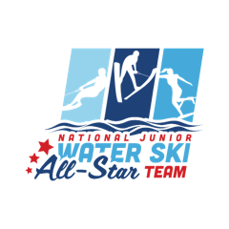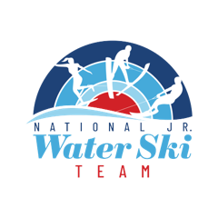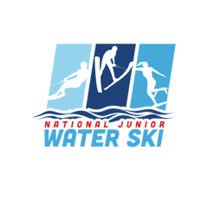

National Junior Development Budget as of 12/01/2021
 | Actual 2021 | Budget 2022 | Actual 2022
Actual & Projected Income:
Regional MI Awards (5 regions @ $300 to $700 in 2022) | $1,500.00 | $3,500.00 | $3,500.00
Online Auction | $7,122.00 | $8,000.00
Banquet Tickets (200 @ $15) | $3,375.46 | $3,500.00
Sponsorships | $0.00 | $5,000.00
Raffle at Nationals | $3,000.00 | $4,000.00
TOTAL INCOME: | $14,997.46 | $24,000.00 | $3,500.00
Actual & Projected Expenses:
Banquet | $3,000.00 | $3,000.00
National Entertainment Budget | $0.00 | $2,000.00
2020 Jr. Team Coaching Stipends (25 @ $300) | $6,000.00 | $0.00 | $0.00
2021 Jr. Team Coaching Stipends (25 @ $200) | $4,600.00 | $0.00 | $0.00
2022 Jr. Team Coaching Stipends (10 @ $200)* | $0.00 | $2,000.00 | $2,400.00
Junior Development Clinics | $0.00 | $5,000.00 | $3,500.00
2021 Eagle Vests (27) | $2,768.00 | $0.00 | $0.00
2022 Jr. Team Swag | $0.00 | $3,000.00 | $2,909.95
All Star Team Swag (6 kids @ 5 regions) | $672.51 | $700.00 | $675.22
Awards for Most Improved (Regional / National) | $4,900.76 | $5,000.00 | $5,474.99
Sponsor Banner | $0.00 | $200.00
TOTAL EXPENSES: | $21,941.27 | $20,900.00 | $14,960.16
Net Gain/Loss | $6,943.81 | $3,100.00
* For kids who cannot attend JD Clinic |  |  | 12 kids
Checking Account Balance as of 12/01/2021 | $9,550.02

AWSA Safety Committee Report
Summer Board of Directors Meeting – August 6th, 2022
Topic 1:
Online Safety Clinic for instructors completed February 19th. Organized by Harley Wallace and Bob Archambeau. The primary purpose was to help Safety Instructors Nationwide become comfortable with the online format for the classroom portion of the approved training course. During our meeting, great questions about our rules and real time experiences were shared. This prompted great discussion that helps to continually shape training and potential adjustments to the rules in place.
Instructors who have people in need of a clinic, or themselves must complete the practical portion of this clinic will administer as their schedule allows.
Topic 2:
The handle Guard discussion addressed at the 2022 winter meeting was sent around to the Regional Safety Chairpersons for discussion. After feedback I furthered this topic with Risk Management. Ultimately new verbiage was agreed upon to update the existing rule regarding approved handles for use in Slalom. The following highlight has been submitted for consideration to the rules committee as an addition to the following rules:
Official Safety Manual
Current rule with proposed highlighted: 5.03 Ropes and Handles, AWSA Specific: Ropes and handles shall not contain any knots that were not specifically inserted by the manufacturer as part of the original rope and handle design. Use of a commercially made handle guard designed to prevent head entrapment is recommended. A handle guard may not diminish the performance of the OEM (Original Equipment Manufacturer) handle.
AWSA Tournament Rules
Current Rule with proposal highlighted: Rule 10.16.2 Skier-Furnished Slalom Handle: The contestant may furnish his own handle, for which he is entirely responsible, with an attaching loop to attach to the tournament line, and which must comply with the handle section dimensions in the Appendix. a.
- The contestant's handle may be of any material.
- Use of a commercially made handle guard designed to prevent head entrapment is recommended. A handle guard may not diminish the performance of the OEM (Original Equipment Manufacturer) handle.
Topic 3:
There were at least 2 Hardship Reinstatement requests received by me, reviewed then sent to Risk Management this semester. I believe they were both approved. More may have occurred. One was for a safety Director who had time away to attend medical school. Now that she has returned, she wanted to make herself available to safety in an area where there aren’t many to do so. I found this encouraging!

Topic 4:
No official complaints have been received. Only hear that Active Member’s want their 90 minutes back after completing the safe sport training.

Kind Regards,
James Cawthern, National Safety Chair

AWSA Seeding Committee Report
Summer Board of Directors Meeting – August 6th, 2022

There is no report for the summer meeting.
Kirby Whetsel

AWSA Skiers Qualification Committee Report
Summer Board of Directors Meeting – August 6th, 2022

There is no report for the summer meeting.
Dave Allen

AWSA Technical Controller Committee Report
Summer Board of Directors Meeting – August 6th, 2022

To: AWSA Board of Directors
From: Jerry Jackson, AWSA Technical Controller Chairman
Action Item:
ACTION #1 Rule 14.04 B: Delete in RED.
For a National Slalom record to be considered, EC video/EC data (BPMS) of the boat path are required (Reference IWWF Rule 8.15.). The EC video/EC Data (BPMS) shall accompany the record application. In addition, for Elite Division National Record in OM, OW, MM & MW video from the boat for the last two passes shall be submitted.
Reason: World Record require Boat Video, but National Records for any Federation should not require boat video to be submitted.
Standard process for all Federation National Record.

ACTION #2 REWRITE NEW in RED
Rule 14.04 C: For a National Jump record to be considered, when using a video-based jump distance measurement system, the application shall include the survey, a copy of the video, a gif formatted file of the record jump, a gif file of the video grid box if in the record jump gif any of the buoys are obscured, and all configuration and setup files appropriate for the system being used to allow independent verification.
Change– For a National Jump record to be considered, the site Chief TC and Chief Judge shall verify the distance and submit the Record Form. Any changes in the scoring resulting from this review shall not change the results of the tournament itself.
Reason: All Federation/National Records are to be approved on site by the Chief Judge and Chief TC. For World Records, all the data is required as identified in IWWF Record Application/Rules. Standard process for all Federation National Record.

ACTION #3 AWSA NATIONAL RECORD APPLICATION FORM
Request to use the IWWF Federation/National and World Record Application Form, Deleting the AWSA National Record Application Form. The IWWF Record Application Form is basically the same as the AWSA National Record Form with a few minor changes. This will require changes in WSTIMS to incorporate these changes.
Reason: Standard Application for all Federation/National and World Records.

INFORMATION ONLY
Video Gate Program – Chip Shand has developed a program that can be loaded on Windows computer with an EASY button for reviewing gates. This program capturing both gate videos in the computer, eliminating the need for DVRs. Deleting all the different operation functions found on the various DVRs. Recommend all tournaments LCO and TCs to download his FREE Gate-Video program from AWSA TC Resources.
Speaking for all TCs and LOCs, we want to Thank Chip Shand for developing these great video programs (Video Gate, Video Tape Measure, Video Stopwatch).
SURE-PATH – There’s a SP Boat Path Monitor program (APK) that can be downloaded/installed on any Android Tablet or Phone to monitor Boat Path (slalom or jump). This allows the judge to see the bread-crumbs and saves the last 25 passes (Version 1.0.5).
http://www.sure-path.com/apks/spboatpathmonitor.apk
Sure-Path includes a Stake-Out Program to install a Slalom or Jump Course. The Buoy-Check now shows the current position with respect to the original position, using cross-hire. Great for finding anchors or re-installing a Jump. (Caution – Do not use ENTRY when using Buoy-Check).
Homologation/TC DOSSIER Report – IWWF Rule 25 is being re-organized, and the Dossier (TC Report) is being re-organized into sections (General/Slalom/Tricks/Jump). Currently, the Dossier Report (checklists) is not in order by events.

SENIOR TC APPLICATION:
In process of changing the requirement for APPLYING for Senior TC. To apply for Senior TC in Slalom or Jump, must hold a regular judges rating in that event. Change the requirement from 2 years to 3 years from Regular TC to Senior TC. Change the Senior TC Application. Will be submitted to BOD at Mid-Winter Meeting.

Respectfully,
Jerry Jackson, AWSA Technical Committee Chairman

AWSA Regional Recommendations
Summer Board of Directors Meeting – August 6th, 2022

Eastern Region –

Midwest Region –

Southern Region –

South Central Region –

Western Region –

AWSA Summer Board of Directors Meeting – August 6th, 2022

Motion to Adjourn

